**Heart Problems Prediction**

**A PROJECT REPORT**

#### Submitted by

Aji Santhosh Kumar Nair (19BCS1903)

Anil Kumar Pradhan (19BCS1898)

Keshav Mishra (19BCS1887)

Sahil Lamba (19BCS1922)

Sahil Mallick (19BCS1073)

***in partial fulfillment for the award of the degree of***

## BACHELOR OF ENGINEERING

**IN**

COMPUTER SCIENCE & ENGINEERING



**Chandigarh University**

AUGUST - DECEMBER, 2022



## BONAFIDE CERTIFICATE

Certified that this project report **“Heart Problems Prediction”** is the bonafide work of “Aji Santhosh Kumar Nair, Anil Kumar Pradhan, Keshav Mishra, Sahil Lamba & Sahil Mallick**”** who carried out the project work under my/our supervision.

<<Signature of the HoD>>

**SIGNATURE**

<<Name of the Head of the Department>>

##### HEAD OF THE DEPARTMENT

<<Department>>

<<Signature of the Supervisor>>

##### SIGNATURE

<<Name>>

##### SUPERVISOR

<<Academic Designation>>

<<Department>>

Submitted for the project viva-voce examination held on

**INTERNAL EXAMINER EXTERNAL EXAMINER**

## TABLE OF CONTENTS

List of Figures iv

List of Tables v

Abstract vi

Abbreviations vii

Chapter 1. Introduction……………………………………………………………1-2

### Client Identification/Need Identification/Identification of relevant Contemporary issue: ................................................................................................…1

* 1. **Identification of Problem……………………………………………………...1**
  2. **Identification of Problem……………………………………………………...2**
  3. **Timeline………………………………………………………………………...2**

### Chapter 2. Literature Review/Background Study………………………………..2-4

**2.1. Timeline of the reported problem…………………………………………….2**

### 2.2. **Proposed Solutions……………………………………………………..….…..4**

**2.3. Objectives……………………………………………………………………...4**

**Chapter 3. Design Flow/Process…………………………………………………..5-19**

**3.1. Evaluation & Selection of Specifications/Features………………………….5**

**3.2. Analysis and Feature finalization subject to constraints……………………7**

**3.3. Design Flow…………………………………………………………………….7**

**3.4. Implementation plan/Methodology……………………………..……………8**

### Chapter 4. Results Analysis and Validation…………………….……………...20-23

**4.1. Performance Analysis………………………………………………………..20**

**4.2. Data Validation………………………………………………………………21**

**4.3. Implementation of solution………………………………………………….22**

**Chapter 5. Conclusion and Future Work…………………………………………23-24**

**5.1. Conclusion………………………………………………………………………..23**

**5.2. Future Work……………………………………………………………………..24**

### References (If Any) .................................................................................................24-25

**Appendix……………………………………………………………………………..26**

**List of Figures**

###### **Figure i. Grant Chart……………………………………………………………..…..2**

**Figure ii. Design Flow of the System…………………………………….…………..……8**

###### **Figure iii. Block Diagram of the System…………………………..…………………………9**

**Figure iv. Correlation Matrix……………………………………………………………….11**

**Figure v. Pairplots..…………………………………………………………………………12**

**Figure vi. ST depression (induced by exercise relative to rest) vs. Heart Disease……………13**

**Figure vii. Thalach Level vs. Heart Disease…………………………………………………..14**

**Figure viii. ST depression Level vs. Heart Disease…………………………………...……….14**

**Figure ix. Feature Importance Graph………………………………………………………..21**

**List of Tables**

**Table 1. Attributes of the Heart disease dataset ………………………………………7**

###### Table 2. Dataset…………………………………………………………………….…….9

**Table 3. Summary of the Dataset………………………………………………………10**

**Table 4. Positive Heart Disease Patients……………………………………………….15**

**Table 5. Negative Heart Disease Patients………………………………………………15**

**Table 6: Confusion Matrix………………………………………………………………20**

## ABSTRACT

One of the most challenging issues in the medical world is the prediction of heart disease. According to recent data, every minute a person dies from heart disease. Processing a vast amount of data in the health care industry requires machine learning. Since predicting cardiac illness is a complex undertaking, it is necessary to automate the process in order to reduce risks and warn the patient well in advance. In this project, we have researched about different models for heart disease prediction through various heart attributes of patient and detect impending heart disease using Machine learning algorithms like Naive Bayes, Decision Tree, Support Vector Machine, K-Nearest Neighbors, Logistic Regression, Random Forest and XGBoost on the dataset available publicly on Kaggle Website, further evaluating the results using confusion matrix and Feature Score. . It is found that Random Forest algorithm gives the ideal accuracy of 80% when compared to other algorithms for heart disease prediction.

**ABBREVIATIONS**

1. ML - Machine learning
2. KNN - K-Nearest Neighbors
3. WHO - World Health Organization
4. SVM - Support Vector Machine
5. XG - Extreme Gradient

**CHAPTER 1**

**INTRODUCTION**

### Client Identification/ Need Identification/ Identification of relevant Contemporary issue:

One of the leading causes of morbidity and mortality among the global population is heart disease. The World Health Organization estimates that heart disease causes 12 million deaths worldwide each year. In the last years ago, the prevalence of heart disease has been rising quickly throughout the world. Numerous studies have been carried out in an effort to identify the most important risk factors for heart disease and to precisely estimate the overall risk. Heart disease is also referred to as a silent killer because it causes a person to pass away without any evident signs. Early detection of heart disease is critical in making decisions about lifestyle adjustments in high-risk patients, which minimizes complications.

Machine learning has been proven to be successful in assisting in decision making and prediction from the huge amount of data provided by the health care sector. This project aims to predict future heart problems by analyzing patient data and determining whether or not they have heart disease using a machine-learning algorithm. Machine Learning techniques can be extremely useful in this regard. Even though heart disease can manifest itself in various ways, there is a common set of key risk factors that impact whether someone is at risk for heart disease or not. We may say that this technique can be extremely well fitted to predict heart disease as it gathers data from numerous sources, classifies it under appropriate headings, and then analyses it to extract the needed data.

### Identification of Problem:

Detecting the heart disease is a difficult task. There are technologies that can be used to predict heart disease, but they are either too expensive or too inefficient to quantify the risk of heart disease in humans. Early identification of heart problems has been shown to reduce mortality and overall consequences. However, it is not possible to precisely monitor patients every day in all circumstances, and 24 hour observation by a doctor is not available because that takes more intelligence, time, and skill. We may use multiple machine learning algorithms to evaluate data for hidden patterns in today's environment because we have a lot of data. Hidden patterns in medical data can be used for health diagnosis.

### Identification of Problem:

The task is to offer a heart disease prediction model for predicting the presence of heart disease.

Furthermore, the purpose of is to find the best classification algorithm for detecting the likelihood of heart disease in a patient. This work is justified by doing a comparison investigation and analysis with seven classification algorithms, namely Naive Bayes, Decision Tree, Support Vector Machine, K-Nearest Neighbors, Logistic Regression, Random Forest and XGBoost, at various degrees of evaluation. Although these are typical machine learning methods, heart disease prediction is a critical task that requires the best possible accuracy. As a result, the seven algorithms are examined at various levels and with various sorts of evaluation procedures. This will allow researchers and medical practitioners to develop a better method.

### Timeline:

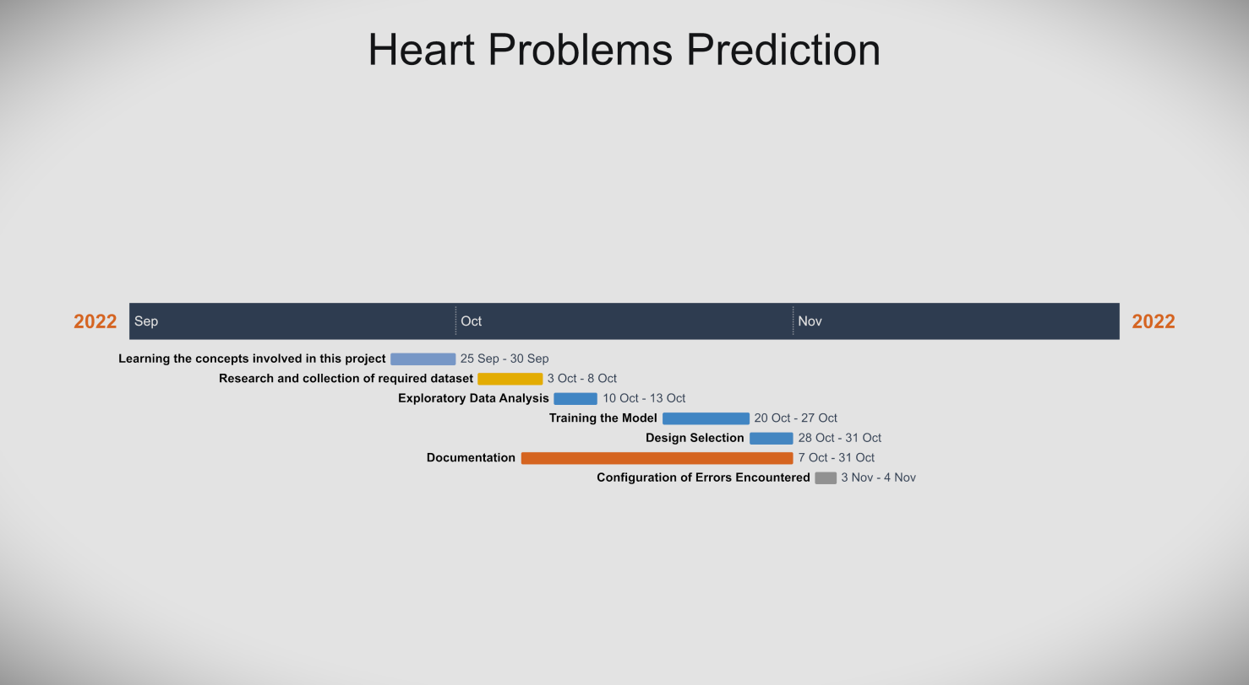

Fig i. Grant Chart

**CHAPTER 2**

**LITERATURE REVIEW/BACKGROUND STUDY**

**2.1. Timeline of the reported problem:**

With the advancement of medical science and machine learning, different experiments and researches have been conducted in recent years, resulting in the publication of major papers.

[1] Purushottam ,et ,al proposed a paper “Efficient Heart Disease Prediction System” using hill climbing and decision tree algorithms .They used Cleveland dataset and preprocessing of data is performed before using classification algorithms. The Knowledge Extraction is done based on Evolutionary Learning (KEEL), an opensource data mining tool that fills the missing values in the data set.A decision tree follows top-down order. For each actual node selected by hill-climbing algorithm a node is selected by a test at each level. The parameters and their values used are confidence. Its minimum confidence value is 0.25. The accuracy of the system is about 86.7%.

[2] Santhana Krishnan. J ,et ,al proposed a paper “Prediction of Heart Disease Using Machine Learning Algorithms” using decision tree and Naive Bayes algorithm for prediction of heart disease. In decision tree algorithm the tree is built using certain conditions which gives True or False decisions. The algorithms like SVM, KNN are results based on vertical or horizontal split conditions depends on dependent variables. But decision tree for a tree like structure having root node, leaves and branches base on the decision made in each of tree Decision tree also help in the understating the importance of the attributes in the dataset. They have also used Cleveland data set. Dataset splits in 70% training and 30% testing by using some methods. This algorithm gives 91% accuracy. The second algorithm is Naive Bayes, which is used for classification. It can handle complicated, nonlinear, dependent data so it is found suitable for heart disease dataset as this dataset is also complicated, dependent and nonlinear in nature. This algorithm gives an 87% accuracy.

[3] Sonam Nikhar et al proposed paper “ Prediction of Heart Disease Using Machine Learning Algorithms” their research gives point to point explanation of Naïve Bayes and decision tree classifier that are used especially in the prediction of Heart Disease. Some analysis has been led to think about the execution of prescient data mining strategy on the same dataset, and the result decided that Decision Tree has highest accuracy than Bayesian classifier.

[4] Aditi Gavhane et al proposed a paper “Prediction of Heart Disease Using Machine Learning”, in which training and testing of dataset is performed by using neural network algorithm multi-layer perceptron. In this algorithm there will be one input layer and one output layer and one or more layers are hidden layers between these two input and output layers. Through hidden layers each input node is connected to output layer. This connection is assigned with some random weights. The other input is called bias which is assigned with weight based on requirement the connection between the nodes can be feedforwarded or feedback.

[5] Avinash Golande et al, proposed “Heart Disease Prediction Using Effective Machine Learning Techniques” in which few data mining techniques are used that support the doctors to differentiate the heart disease. Usually utilized methodologies are k-nearest neighbour, Decision tree and Naïve Bayes. Other unique characterization-based strategies utilized are packing calculation, Part thickness, consecutive negligible streamlining and neural systems, straight Kernel selfarranging guide and SVM (Bolster Vector Machine).

[6] Lakshmana Rao et al,proposed “Machine Learning Techniques for Heart Disease Prediction” in which the contributing elements for heart disease are more. So, it is difficult to distinguish heart disease.To find the seriousness of the heart disease among people different neural systems and data mining techniques are used.

[7] Abhay Kishore et alproposed “Heart Attack Prediction Using Deep Learning” in which heart attack prediction system by using Deep learning techniques and to predict the probable aspects of heart related infections of the patient Recurrent Neural System is used. This model uses deep learning and data mining to give the best precise model and least blunders. This paper acts as strong reference model for another type of heart attack prediction models.

[8] Senthil Kumar Mohan et al, proposed “Effective Heart Disease Prediction Using Hybrid Machine Learning Techniques” in which their main objective is to improve exactness in cardiovascular problems. The algorithms used are KNN, LR, SVM, NN to produce an improved exhibition level with a precision level of 88.7% through the prediction model for heart disease with hybrid random forest with linear model(HRFLM).

[9] Anjan N. Repaka et al, proposed a model stated the performance of prediction for two classification models, which is analyzed and compared to previous work. The experimental results show that accuracy is improved in finding the percentage of risk prediction of our proposed method in comparison with other models.

[10] Aakash Chauhan et al, proposed “Heart Disease Prediction using Evolutionary Rule Learning”. Data is directly retrieved from electronic records that reduce the manual tasks. The amount of services are decreased and shown major number of rules helps within the best prediction of heart disease. Frequent pattern growth association mining is performed on patient’s dataset to generate strong association.

**2.2. Proposed Solutions:**

Previous study has looked into the use of machine learning techniques in the prediction and classification of heart disease. These research, however, concentrate on the specific effects of certain machine learning approaches rather than on the optimization of these techniques utilising optimised methodologies. Furthermore, few researchers attempted to implement hybrid optimization approaches for machine learning classification optimization. The majority of research proposed in the literature combine optimized approaches like Particle Swarm Optimization and Ant Colony Optimization with a specific ML technique like SVM, KNN, or Random Forest.

As a first phase, the Fast Correlation-Based Feature Selection (FCBF) approach was used in this work (pre-treatment). When all continuous attributes are discretized, the mining-relevant attribute selection attributes are chosen from among all the original attributes. As a pre-processing step to machine learning, feature selection is effective in lowering dimensionality, eliminating unnecessary data, enhancing learning accuracy, and improving understanding of findings. In the second stage, PSO and ACO are used to pick the relevant data set characteristics. The optimum subset of features chosen by the characteristic selection methods improves classification accuracy. As a result, in the third phase, classification methods are used to diagnose heart disease, and classification accuracy is measured to evaluate the performance of characteristic selection methods.

**2.3. Objectives:**

Following are major objectives of this project:

1. Developing a machine learning model to predict the likelihood of future heart disease.
2. Identifying major risk factors for heart diseases based on a medical dataset.
3. Analyzing feature selection methods and understanding their performance.

**CHAPTER 3**

**DESIGN FLOW/PROCESS**

* 1. **Evaluation & Selection of Specifications/Features :**

We have used various machine-learning algorithm to train our system. These algorithms are discussed below in detail.

1. **Logistic Regression:**

Logistic regression is a popular Machine Learning method that belongs to the Supervised Learning technique. It is used to predict the categorical dependent variable from a set of independent variables. A categorical dependent variable's output is predicted using logistic regression. As a result, the outcome must be categorical or discrete. It can be Yes or No, 0 or 1, true or False, but instead of presenting the exact values like 0 and 1, it presents the probability values that fall between 0 and 1.

In Logistic regression, instead of constructing a regression line, we fit a "S" shaped logistic function that predicts two maximum values (0 or 1).

The logistic function curve reflects the possibility of something such as whether the cells are cancerous or not, whether a mouse is obese or not based on its weight, and so on.

Logistic Regression is an important algorithm for machine learning because it can generate probabilities and classify new data using both continuous and discrete datasets.

1. **Naive Bayes Algorithm:**

The Naive Bayes algorithm is a supervised learning technique that uses the Bayes theorem to solve classification issues. It is mostly utilized in text classification with a large training dataset.

The Naive Bayes Classifier is a basic and effective Classification method that helps in the development of fast machine learning models capable of making quick predictions.

It is a probabilistic classifier, which means it predicts based on an object's likelihood. Spam filtration, sentiment analysis, and article classification are some popular applications of the Nave Bayes Algorithm.

It is a classification method based on Bayes' Theorem and the assumption of predictor independence. A Naive Bayes classifier, in simple terms, assumes that the existence of one feature in a class is unrelated to the presence of any other feature.

The Naive Bayes model is simple to implement and especially useful for very big data sets. In addition to its simplicity, Naive Bayes has been shown to beat even the most advanced classification systems.

1. **Decision Tree Algorithm:**

Decision Tree is a Supervised learning technique algorithm that can be used to solve classification and regression problems, however it is most commonly used to solve classification problems. It is a tree-structured classifier in which internal nodes contain dataset attributes, branches represent decision rules, and each leaf node represents the result. A Decision Tree has two nodes: the Decision Node and the Leaf Node.

Decision nodes are used to make decisions and have numerous branches, whereas Leaf nodes represent the results of those decisions and do not have any additional branches. The decisions or tests are based on the characteristics of the given dataset. It is a graphical representation of all possible solutions to a problem/decision given certain parameters. It is termed a Decision Tree because, like a tree, it begins with the root node and then branches out to form a tree-like structure. The CART algorithm, which stands for Classification and Regression Tree algorithm, is used to form a tree. A Decision Tree simply asks a question and split the tree into subtrees based on the answer (Yes/No).

1. **Random Forest Algorithm:**

Random Forest is a popular supervised learning algorithm. It is an extension of machine learning classifiers that includes bagging to improve Decision Tree performance. It combines tree predictors, and the trees are reliant on a random vector that is sampled independently. All trees have the same distribution. Instead of splitting nodes based on variables, Random Forests separates nodes by selecting the best predictor subset from the node itself. The worst-case temporal complexity of Random Forests learning is O(M(dnlogn)), where M represents the number of growing trees, n represents the total number of occurrences, and d represents the data dimension.

It can be used for classification as well as regression. It is also the most adaptable and user-friendly algorithm. A forest is made up of trees. It is assumed that the more trees a forest has, the more robust it is. Random Forests generate Decision Trees from randomly picked data samples, obtain predictions from each tree, then vote on the best option. It also serves as a good indicator of the feature importance.

1. **Support Vector Machine (SVM):**

SVM, or Support Vector Machine, is a prominent Supervised Learning technique that is used for both classification and regression problems. However, it is mostly useful in Machine Learning for Classification problems.

The SVM algorithm's purpose is to find the optimum line or decision boundary for categorising n-dimensional space so so that we can easily place new data points in the correct category in the future. A hyperplane is the best choice boundary. SVM selects the extreme points/vectors that help in the creation of the hyperplane. These extreme situations are known as support vectors, and the algorithm is known as the Support Vector Machine.

1. **K Nearest Neighbor (KNN):**

K Nearest Neighbor (KNN) is a machine learning technique which is simple, simple to understand and versatile. KNN is useful in many areas, including banking, healthcare, political science, handwriting recognition, image identification, and video recognition. Financial institutions will predict consumers' credit ratings in credit ratings. Banking institutions will predict if a loan is safe or dangerous during loan disbursement. In political science, potential voters are divided into two groups: those who will vote and those who will not vote. The KNN technique is applied to classification and regression problems. The KNN algorithm is based on the feature similarity method.

1. **XG-boost Algorithm:**

XG-boost is an implementation of Gradient Boosted decision trees. It is a type of software library that was created to improve model speed and performance. This technique generates decision trees in a sequential fashion. Weights are very significant in XG-boost. All of the independent variables are given weights, which are subsequently fed into the decision tree, which predicts results. The weight of variables incorrectly predicted by the tree is increased, and these variables are subsequently fed into the second decision tree. These various classifiers/predictors are then combined to form a more powerful and precise model. It is capable of doing regression, classification, ranking, and user-defined prediction.

* 1. **Analysis and Feature finalization subject to constraints:**

Of the 76 attributes available in the dataset, 13 attributes are considered for the prediction of the output. The predictor for the diagnosis of Heart Disease in our project is determined by these 13 features. All attributes are listed in ‘Table 1’.

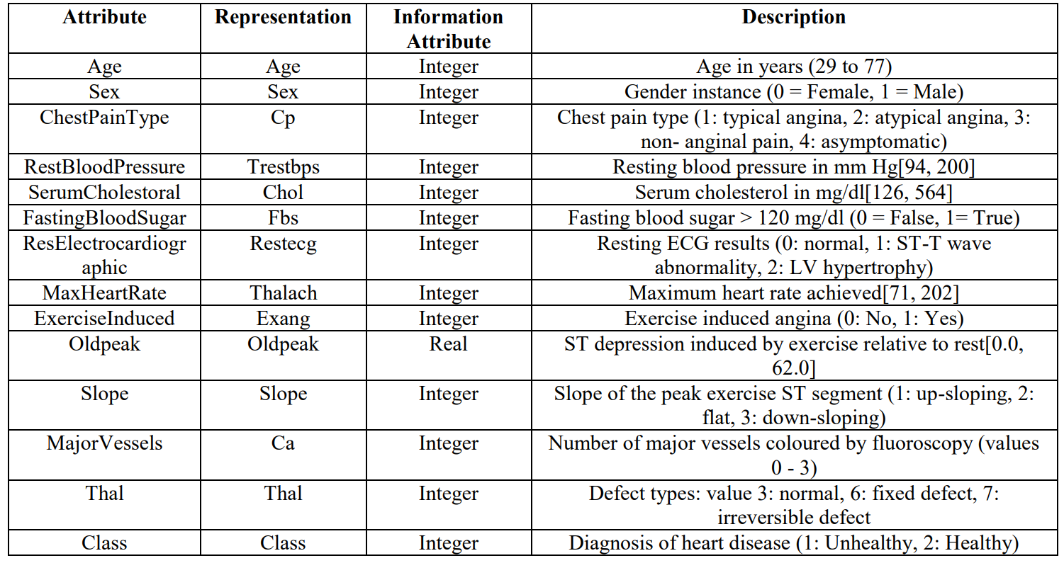

Table 1. Attributes of the Heart disease dataset

* 1. **Design Flow:**

The design flow of our system is described below:

Dataset collection is the process of gathering information on patients.

The process of selecting useful attributes for the prediction of heart disease is known as attribute selection. Following the identification of available data resources, they are further processed, cleansed, and transformed into the suitable form. Different classification techniques (as mentioned above) will be used on preprocessed data to predict the accuracy of heart disease. The accuracy metric compares the accuracy of various classifiers.

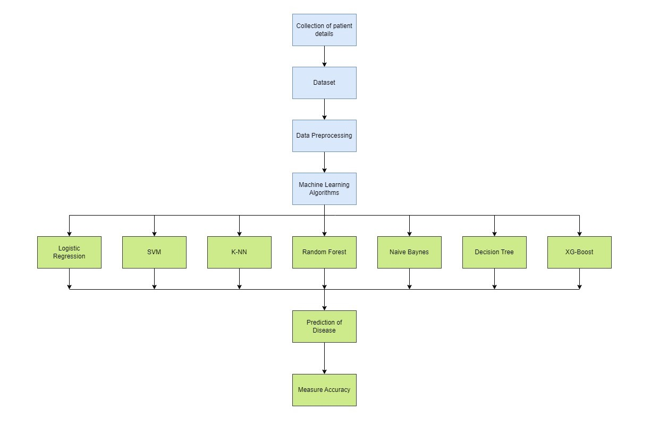

Fig ii. Design Flow of the System

Our heart disease prediction system is comparable to Fig. ii, which also describes the research methods for creating a classification model needed for the prediction of heart problems in patients. The model serves as the foundation for predicting heart disease using any machine learning technique. To make predictions, a classifier must be trained using the dataset, and then a classification model must be created, which is then fed a new unknown record, and the forecast is formed.

* 1. **Implementation plan/Methodology:**

This project is implement using the following modules:

1. Data Wrangling
2. Exploratory Data Analysis
3. Model Training Using Machine Learning Algorithms
4. Finding Feature Importance.

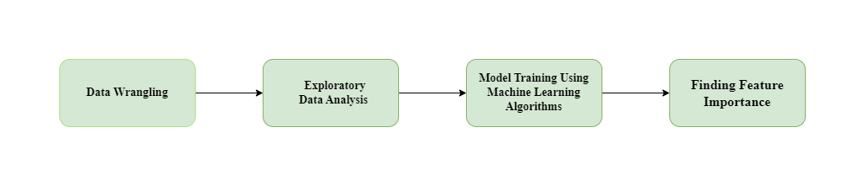

Fig iii. Block Diagram of the System

* + 1. **Data Wrangling:**

First we will import the required libraries and dataset then we'll start by converting the dataset we're working with into a simpler and more readable format.

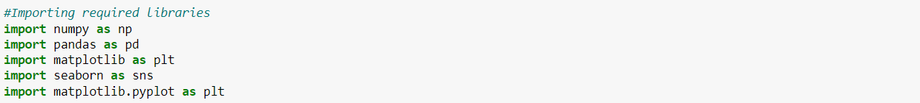

The above code helped us display our data in tabular form.

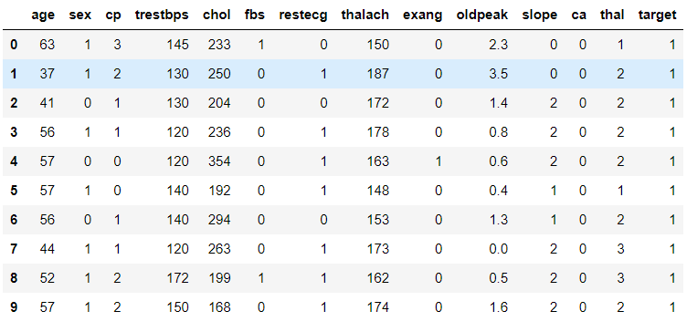

Table 2. Dataset

The following code will give us the total number of rows and columns and the column names in our dataset. The total number of rows and columns in our data is 303 and 14 respectively. Then we will use the data.nunique() function to get the number of unique values for every variable.

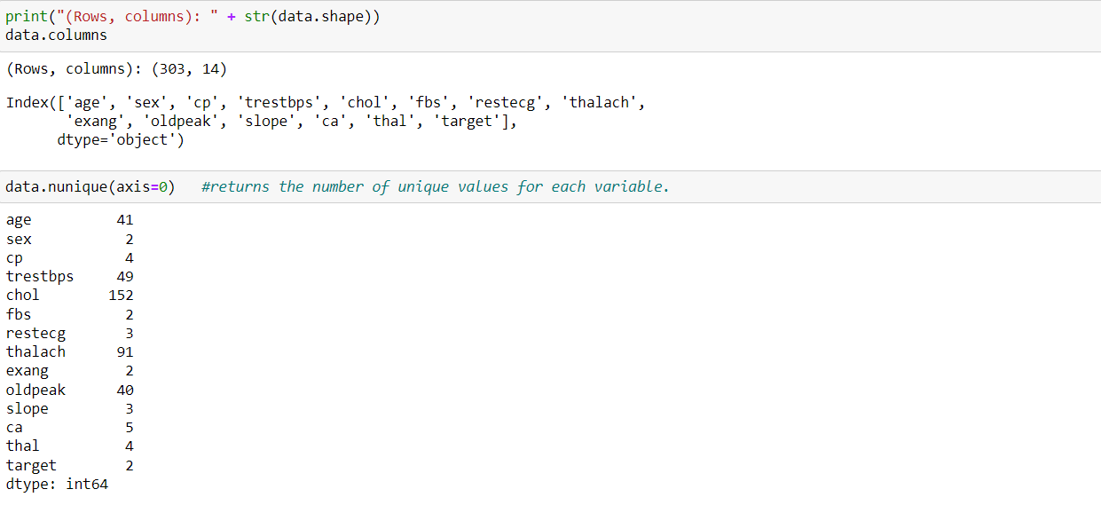

In the next step, we will use data.describe() to summarize the count, mean, standard deviation, min, and max for numeric variables.



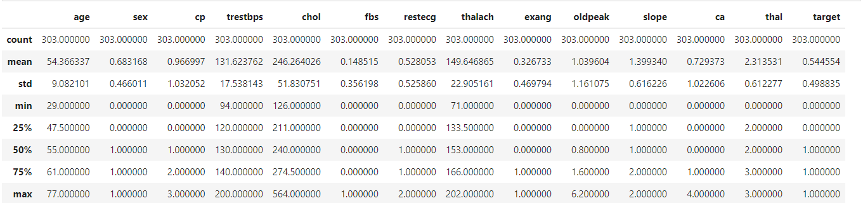

Table 3. Summary of the Dataset

* + 1. **Exploratory Data Analysis:**

After completing data wrangling, we are going to perform exploratory data analysis. We will perform some primary tasks at this stage.

**Finding Correlations:**

We will built a correlation matrix to see whether something is positively or negative correlated with our predictor.

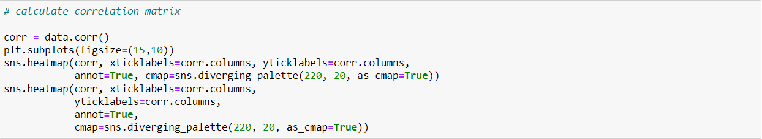

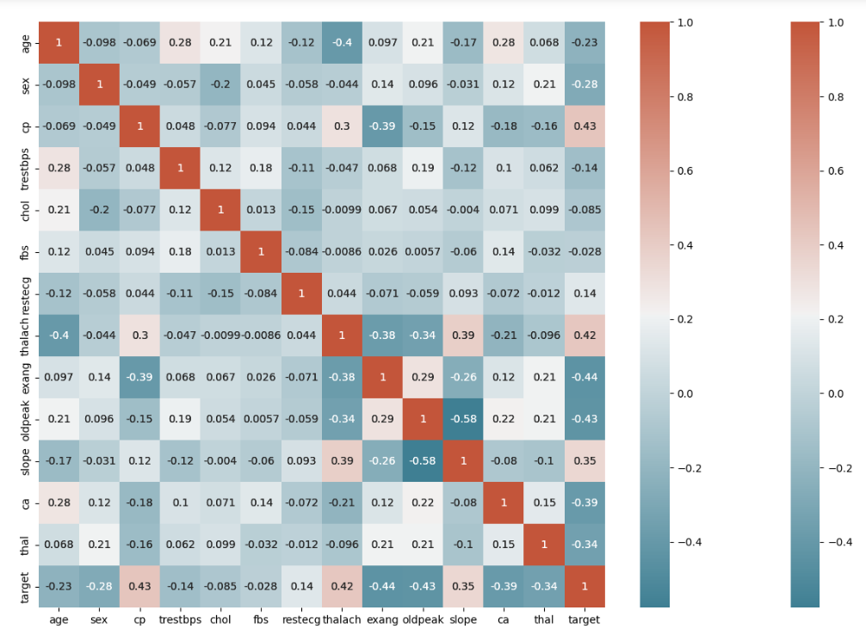

Fig iv. Correlation Matrix

We can observe that there is a positive correlation between chest pain (cp) and the target (our predictor). This makes sense because having more chest pain increases the chances of developing heart disease. Cp (chest pain) is a four-valued ordinal feature with 4 values:

Value 1: typical angina ,Value 2: atypical angina, Value 3: non-anginal pain , Value 4: asymptomatic.

Furthermore, there is a negative correlation between exercise-induced angina (exang) and our predictor. This makes sense because the heart wants more blood when you exercise, but narrower arteries restrict blood flow.

Pairplots are also an excellent way to see the correlations between all variables. But we'll construct it with only continuous columns from our data because seeing each one can be challenging with so many features. Instead, we'll create a pairplot using solely our continuous features.



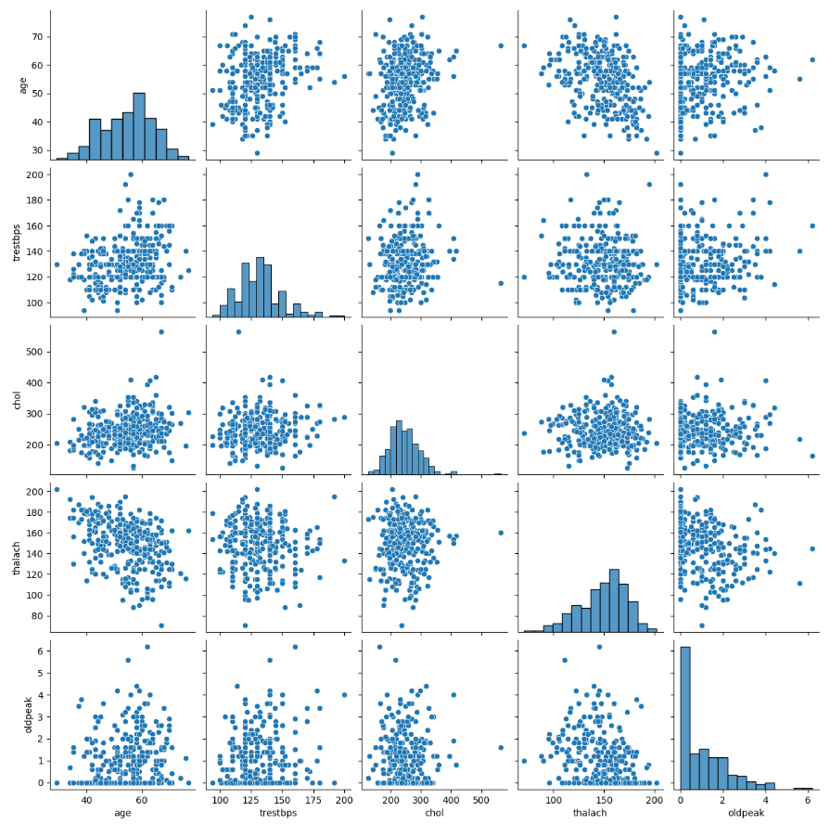

Fig v. Pairplots

To look more deeply into the correlations, We created a smaller pairplot with only the continuous variables. Also useful for determining whether there is a positive or negative correlation.



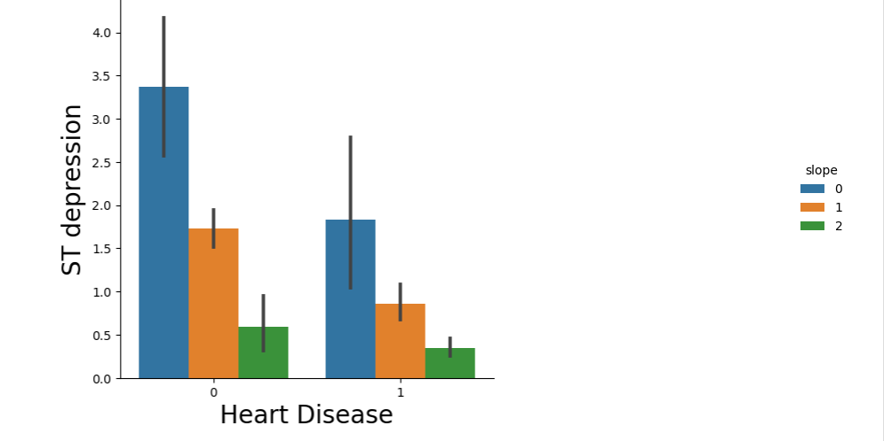

Fig vi. ST depression (induced by exercise relative to rest) vs. Heart Disease

When the ventricle is at rest and hence repolarized, ST segment depression occurs. This heart disease can occur if the trace in the ST segment is pretty low below the baseline. This supports the plot above because those with low ST Depression are more likely to develop heart disease. While a high ST depression is natural and healthy. The slope hue relates to the peak workout ST segment, with values ranging from 0 to 2 (upsloping, flat, and downsloping). Patients with positive and negative heart disease had equal distributions of the three slope groups.

**Using Violin and Box Plots:**

The Violin and Box plots can be used for displaying the basic statistics of the data as well as its distribution. These plots are frequently used to compare the distribution of a variable across different categories. It displays the median, interquartile range, and Tukey's fence (minimum, first quartile (Q1), median, third quartile (Q3), and maximum). Furthermore, it can identify outliers in our data.



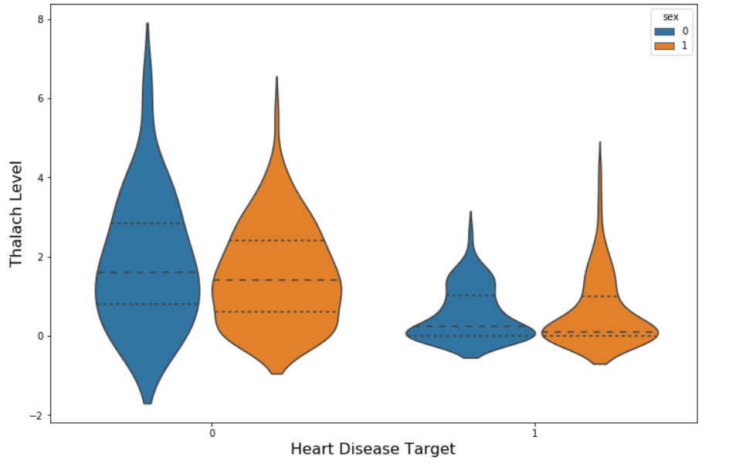

Fig vii. Thalach Level vs. Heart Disease

The overall shape and distribution of negative and positive patients differ dramatically. Positive patients have a lower median for ST depression level and consequently a wide dispersion of their data between 0 and 2, whereas negative patients have a distribution between 1 and 3. Furthermore, there aren't many differences between male and female target outcomes.

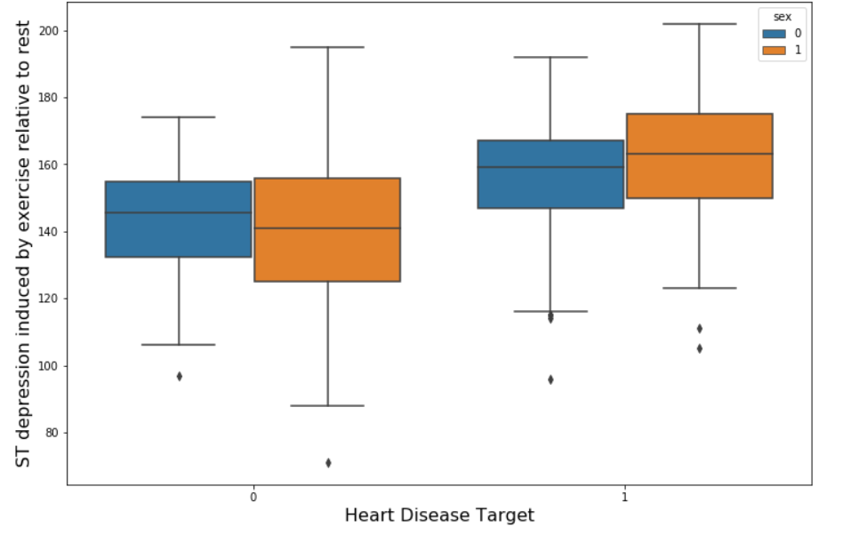

Fig viii. ST depression Level vs. Heart Disease

Positive patients had a higher median level of ST depression, whereas negative patients have lower levels. Furthermore, we don't noticesee any significant differences between male and female target outcomes, except for males having slightly greater ranges of ST Depression.

**Filtering data by positive & negative Heart Disease patient:**

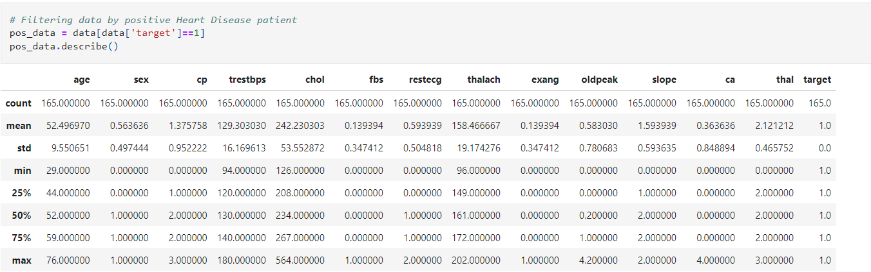

Table 4. Positive Heart Disease Patients

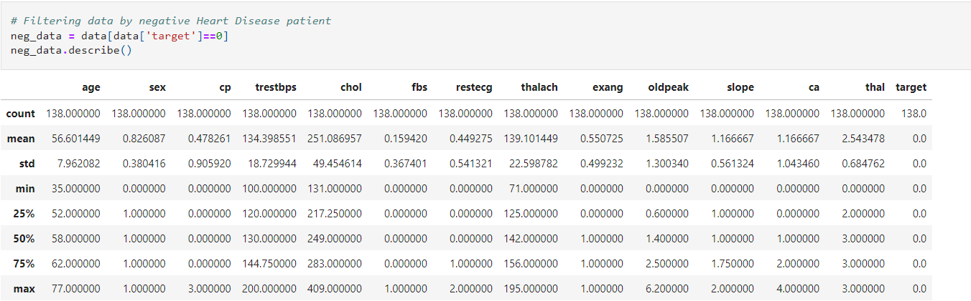

Table 5. Negative Heart Disease Patients

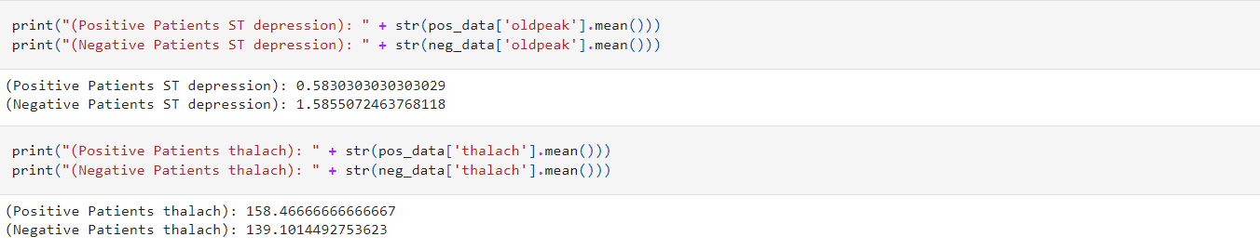

When we compare positive and negative patients, we can observe that there are significant differences in means for several of our features. Examining the facts reveals that positive patients have a higher average maximal heart rate reached (thalach). Furthermore, positive individuals have roughly one-third the amount of ST depression caused by activity compared to rest (oldpeak).

* + 1. **Model Training Using Machine Learning Algorithms:**

**Preparing the Data for Modeling:**

First, assign the 13 features to X and the last column to the predictor Y. Then, we’ll split the data into two sets I.e., training set and test set. Finally, we'll normalise the data so that its distribution has a mean of zero and a standard deviation of 1.

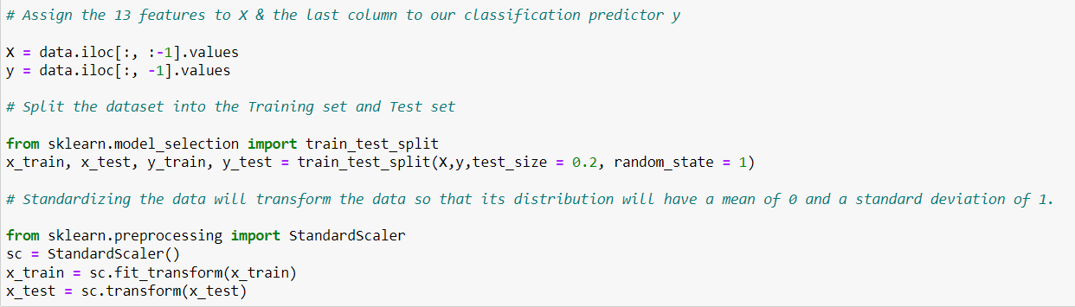

**Training:**

Now, we will train various Classification Models on the training set to discover which one produces the highest accuracy. Then, the accuracy of Logistic Regression, K-NN, SVM, Naives Bayes Classifier, Decision Trees, Random Forest, and XGBoost will be compared.

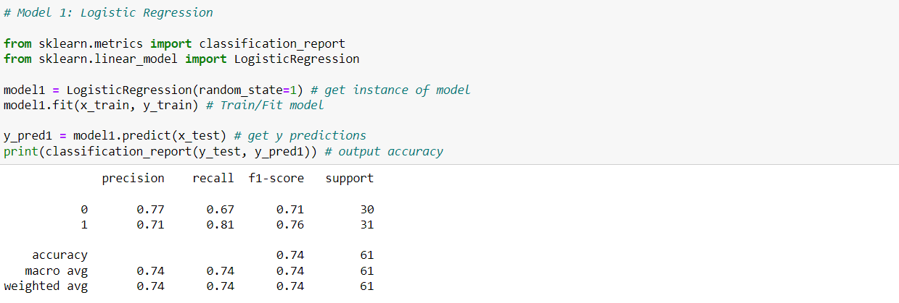

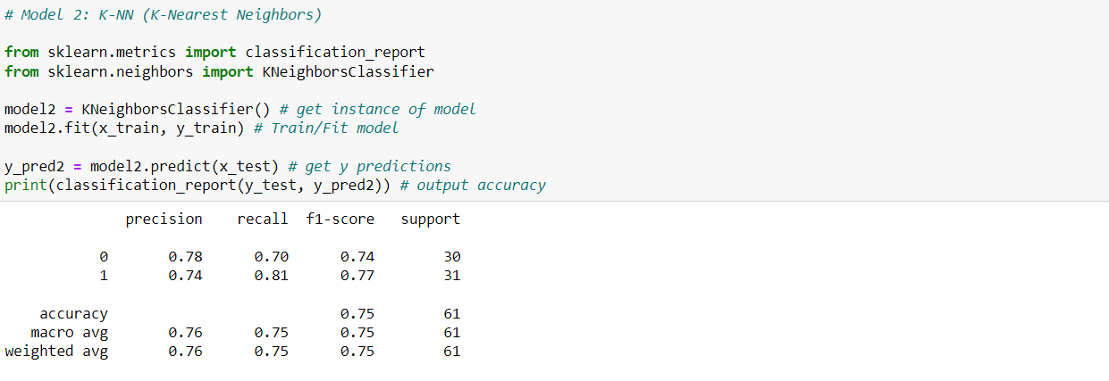

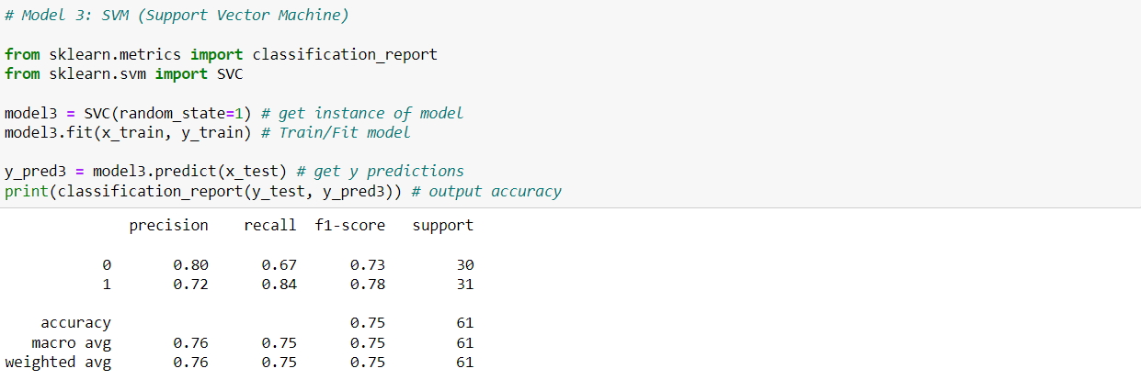

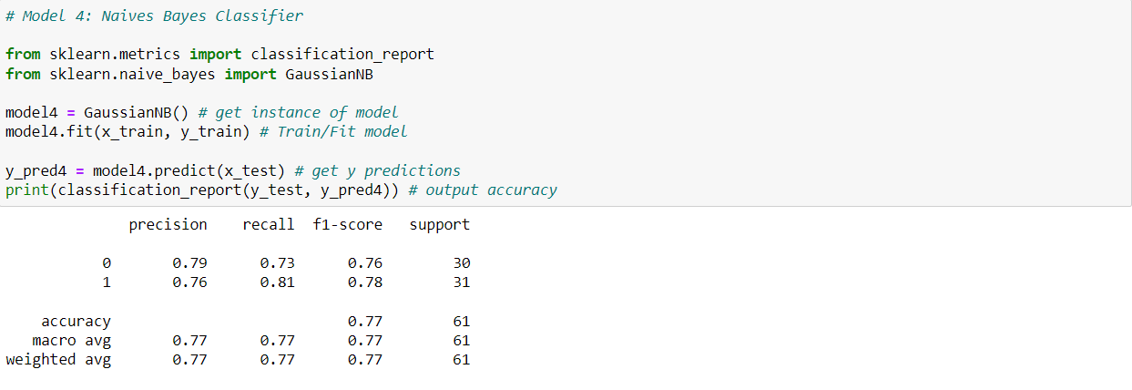

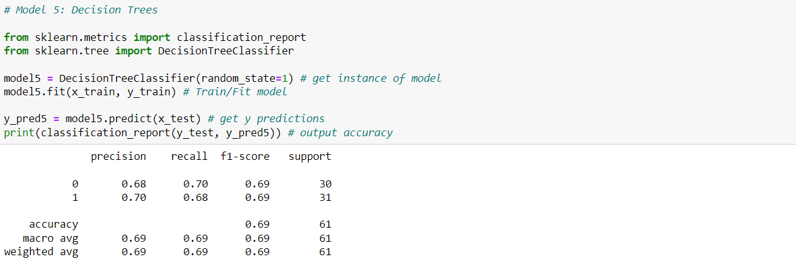

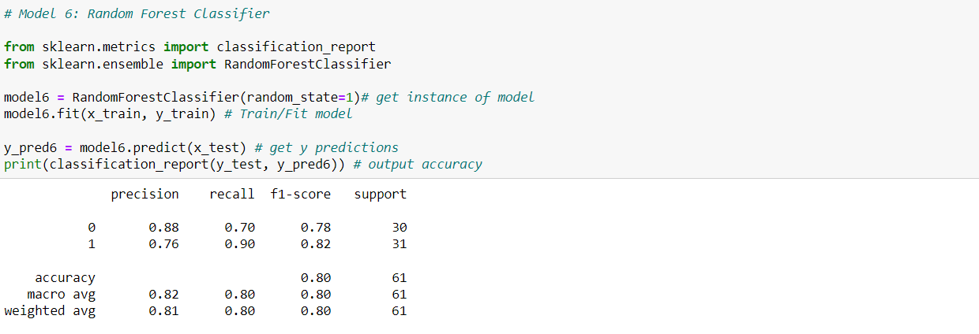

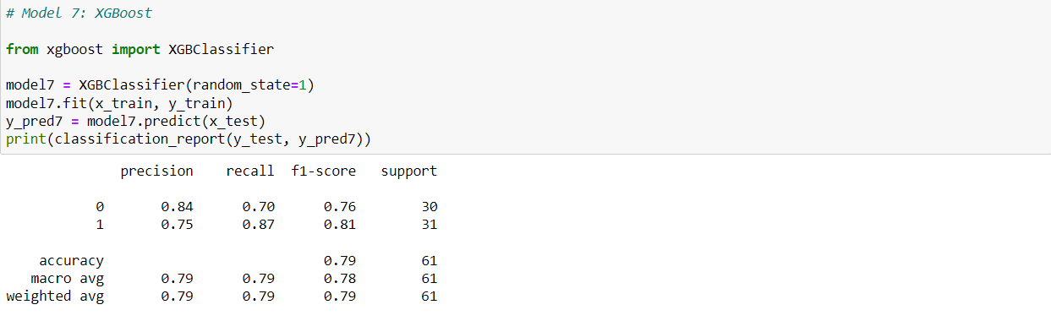

We can conclude from comparing the seven models that Model 6: Random Forest has the highest accuracy with an 80% accuracy.

We have precision, recall, F1-score and support:

Precision may be defined as "how many patient in that class are accurately classified."

Recall may be defined as "how many of this class you find out of the total number of elements in this class"

The F1-score is the harmonic mean of the precision and recall scores.

The F1 score reaches its highest value at 1 and its lowest value at 0.

F1 Score = 2 * (precision x recall) / (precision + recall)

Support is the number of true response samples in that class.

**Making the Confusion Matrix:**

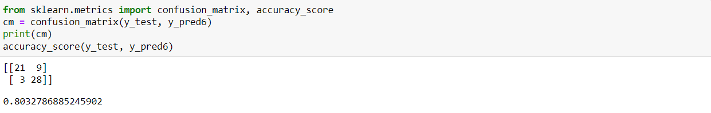

The number of True Positives in our data is 21, whereas the number of True Negatives is 28.

The amount of errors is 9 & 3.

* + 1. **Finding Feature Importance**:

Feature Importance calculates a score indicating on how useful each feature was in our model. The higher the Feature Score, the more frequently that feature is used to make vital decisions, making it more essential.

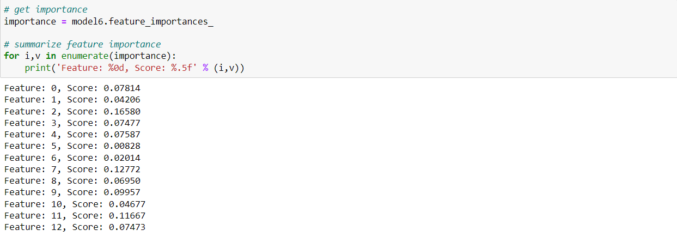

**CHAPTER 4**

**RESULTS ANALYSIS AND VALIDATION**

* 1. **Performance Analysis:**

For evaluating the experiment, various evaluation metrics like accuracy, confusion matrix, precision, recall, and f1-score are considered.

**Confusion Matrix:**

A confusion matrix, also called as an error matrix, is a table that is used to describe the performance of a classification model (or "classifier") on a collection of test data with known true values. It enables the visualization of an algorithm's performance. It enables easy identification of class confusion, such as when one class is frequently mislabeled as the other. The key to the confusion matrix is that the number of correct and incorrect predictions, as well as the number of errors made, are summed with count values and broken down by class.

|  |  |
| --- | --- |
| TP=21 | FP=9 |
| FN=3 | TN=28 |

Table 6: Confusion Matrix

Here,

• TP represents True Positive = Observation is positive and is predicted to be positive.

• FN represents False Negative = Observation is positive but is predicted negative.

• TN represents True Negative = Observation is negative and is predicted to be negative.

• FP represents False Positive = Observation is negative but is predicted positive.

**Accuracy:**

Accuracy is defined as the ratio of correct predictions to total inputs in the dataset.

It is given as follows:

Accuracy = (TP + TN)/(TP+FP+FN+TN) = (21+28)/(21+28+9+3) = 0.80 = 80% accuracy

Any accuracy beyond 70% is regarded good but if the accuracy is too high, it may be too good to be true (an example of Overfitting). As a result, 80% accuracy is optimal.

**Recall:**

The ratio of the total number of correctly categorized positive examples divided by the total number of positive examples is known as recall. High recall suggests that the class was accurately identified (a small number of FN). Recall is calculated as follows:

Recall = TP/(TP+FN) = 21/(21+3) = 0.875

**Precision:**

Precision is calculated by dividing the total number of correctly classified positive examples by the total number of predicted positive examples. High Precision means that an example labelled as positive is, in fact, positive (a small number of FP). Precision is expressed as:

Precision = TP/(TP+FP) = 21/(21+9) = 0.7

**F1-Score:**

F1-score is the harmonic mean of Precision and recall. It measures the accuracy of the test. This measure has a scale of 0 to 1.

F1 Score = 2 x ((precision * recall) / (precision + recall)) = 2(0.7*0.875)/(0.7+0.875) = 0.78

* 1. **Data Validation:**

**Feature Selection:**

The top four significant features, according to the Feature Importance graph (Fig), were chest pain type (cp), maximal heart rate achieved (thalach), number of main vessels (ca), and ST depression generated by exercise relative to rest (oldpeak).

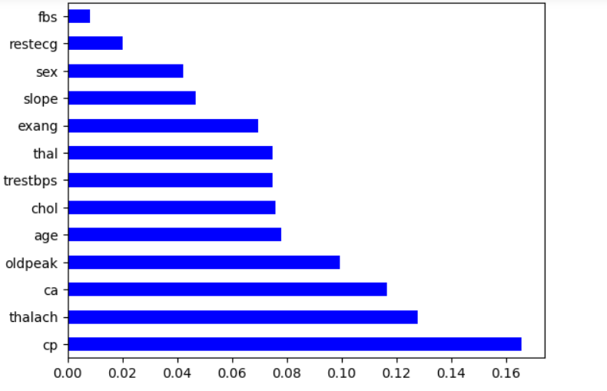

Fig ix. Feature Importance Graph

* 1. **Implementation of solution:**

**Scenario:**

When a patient begins to experience cardiac symptoms, we enter his vitals into the Machine Learning Algorithm.

He is a 20-year-old male with a score of 2 for chest pain (atypical angina) and a resting blood pressure of 110.

He also has a blood cholesterol level of 230 mg/dl.

He has fasting blood sugar levels that exceed 120 mg/dl.

His resting electrocardiogram result is 1.

The patient's maximal heart rate is 140.

He also had exercise-induced angina.

His exercise-induced ST depression was 2.2 compared to his rest value.

The peak exercise ST segment has a level slope.

He has no major vessels that are visible under fluoroscopy, and his maximal heart rate is a reversible abnormality.

Based on this information we can classify whether this patient has Heart Disease or not.



Yes! Our machine learning algorithm has detected that this patient has a Heart Disease. Now we can correctly diagnose him and get him the treatment he requires to recover. We may be able to prevent worse symptoms from appearing later.

**Predicting the dataset results:**

The first value is our predicted value, while the second value is our actual value. If the values match, we accurately predicted. Our results are quite accurate, as we can see below.



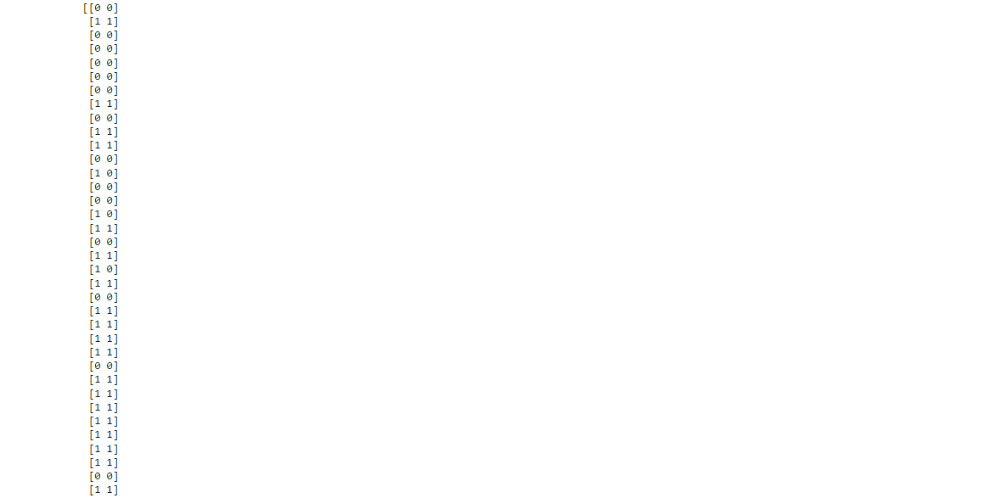

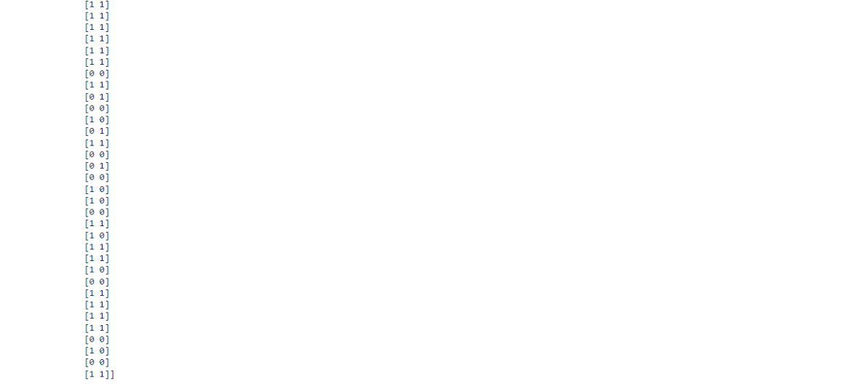

**CHAPTER 5**

**CONCLUSION AND FUTURE WORK**

**5.1. Conclusion:**

Heart disease is a major killer in India and around the world; applying promising technology such as machine learning to the early prediction of heart disease would have a significant influence on society. Early detection of heart disease can help high-risk patients make lifestyle changes and, as a result, prevent complications, which can be an important achievement in the area of medicine. Every year, more people are diagnosed with heart disease. This requires an early diagnosis and therapy. The use of appropriate technology support in this area can be extremely valuable to the medical community and patients. Logistic Regression, Nave Bayes, SVM, Decision Tree, K-NN, Random Forest and XGBoost are the seven machine learning algorithms used to in this project.

The projected attributes leading to heart disease in patients are present in the dataset, which contains 76 features, 13 of which are crucial for evaluating the system. If all of the features are taken into account, our system will have a lower efficiency. Attribute selection is done to improve efficiency. In this case, n features must be chosen in order to evaluate the model with greater accuracy. Because the correlation of several features in the dataset is almost equal, they are discarded. When all of the attributes in the dataset are included, the efficiency drops dramatically.

The accuracies of all seven machine learning methods are compared, and one prediction model is developed as a result. Hence, the goal is to use multiple evaluation measures such as confusion matrix, accuracy, precision, recall, and f1-score to efficiently predict the disease. When all seven are compared, the extreme Random Forest algorithm has the greatest accuracy of 80%.

**5.2. Future Work:**

The future work in this area can be made to produce an impact on the accuracy of the various classification algorithms. For additional improvement applying genetic algorithm in order to reduce the actual data for acquiring the optimal subset of attribute that is perfectly adequate for heart disease prediction. The automated prediction of heart disease using actual real-time data from health care organizations that can be produced using big data. They can be fed as streaming data, and using the data, a real-time study of the patients can be prepared.

**REFERENCES**

1. Soni J, Ansari U, Sharma D & Soni S (2011). Predictive data mining for medical diagnosis: an overview of heart disease prediction. International Journal of Computer Applications, 17(8), 43-8
2. Dangare C S & Apte S S (2012). Improved study of heart disease prediction system using data mining classification techniques. International Journal of Computer Applications, 47(10), 44-8.
3. Ordonez C (2006). Association rule discovery with the train and test approach for heart disease prediction. IEEE Transactions on Information Technology in Biomedicine, 10(2), 334-43.
4. Shinde R, Arjun S, Patil P & Waghmare J (2015). An intelligent heart disease prediction system using k-means clustering and Naïve Bayes algorithm. International Journal of Computer Science and Information Technologies, 6(1), 637-9.
5. Bashir S, Qamar U & Javed M Y (2014, November). An ensemble-based decision support framework for intelligent heart disease diagnosis. In International Conference on Information Society (i-Society 2014) (pp. 259-64). IEEE. ICCRDA 2020 IOP Conf. Series: Materials Science and Engineering 1022 (2021) 012072 IOP Publishing doi:10.1088/1757-899X/1022/1/012072 9
6. Jee S H, Jang Y, Oh D J, Oh B H, Lee S H, Park S W & Yun Y D (2014). A coronary heart disease prediction model: the Korean Heart Study. BMJ open, 4(5), e005025.
7. Ganna A, Magnusson P K, Pedersen N L, de Faire U, Reilly M, Ärnlöv J & Ingelsson E (2013). Multilocus genetic risk scores for coronary heart disease prediction. Arteriosclerosis, thrombosis, and vascular biology, 33(9), 2267-72.
8. Jabbar M A, Deekshatulu B L & Chandra P (2013, March). Heart disease prediction using lazy associative classification. In 2013 International MutliConference on Automation, Computing,Communication, Control and Compressed Sensing (iMac4s) (pp. 40- 6). IEEE.
9. Brown N, Young T, Gray D, Skene A M & Hampton J R (1997). Inpatient deaths from acute myocardial infarction, 1982-92: analysis of data in the Nottingham heart attack register. BMJ, 315(7101), 159-64.
10. Folsom A R, Prineas R J, Kaye S A & Soler J T (1989). Body fat distribution and self-reported prevalence of hypertension, heart attack, and other heart disease in older women. International journal of epidemiologyy, 18(2), 361-7.

* Rohit Bharti, Aditya Khamparia, Mohammad Shabaz, Gaurav Dhiman, Sagar Pande, Parneet Singh, "Prediction of Heart Disease Using a Combination of Machine Learning and Deep Learning", Computational Intelligence and Neuroscience, vol. 2021, Article ID 8387680, 11 pages, 2021. https://doi.org/10.1155/2021/8387680
* Applying k-Nearest Neighbour in Diagnosing Heart Disease Patients Mai Shou, Tim Turner, and Rob Stocker International Journal of Information and Education Technology, Vol. 2, No. 3, June 2012.
* Internet source [Online].Available at: <http://acadpubl.eu/ap>

**APPENDIX**

**Python:**

Python is an interpreted, high-level, general purpose programming language created by Guido Van Rossum and first released in 1991, Python's design philosophy emphasizes code Readability with its notable use of significant White space. Its language constructs and object oriented approach aim to help programmers write clear, logical code for small and large-scale projects. Python is dynamically typed and garbage collected. It supports multiple programming paradigms, including procedural, object-oriented, and functional programming.

**Pandas:**

Pandas is an open-source library that is made mainly for working with relational or labeled data both easily and intuitively. It provides various data structures and operations for manipulating numerical data and time series. This library is built on top of the NumPy library. Pandas is fast and it has high performance & productivity for users.

**Seaborn:**

Seaborn is a Python data visualization library based on matplotlib. It provides a highlevel interface for drawing attractive and informative statistical graphics. Seaborn is a library in Python predominantly used for making statistical graphics. Seaborn is a data visualization library built on top of matplotlib and closely integrated with pandas data structures in Python. Visualization is the central part of Seaborn which helps in exploration and understanding of data.

**Matplotlib:**

Matplotlib is a plotting library for the Python programming language and its numerical mathematics extension NumPy. It provides an object-oriented API for embedding plots into applications using general-purpose GUI toolkits like Tkinter, wxPython, Qt, or GTK. There is also a procedural "pylab" interface based on a statemachine (like OpenGL), designed to closely resemble that of MATLAB, though its use is discouraged.

**Sklearn:**

Scikit-learn (Sklearn) is the most useful and robust library for machine learning in Python. It provides a selection of efficient tools for machine learning and statistical modeling including classification, regression, clustering and dimensionality reduction via a consistent interface in Python. This library, which is largely written in Python, is built upon NumPy, SciPy and Matplotlib.